Visit an exhibition “#StandWithUkraine. The Russian war of aggression against Ukraine: lives taken, destroyed cities, lost fortunes”
The exhibition of photo and video materials aims to present the shocking realities of the Russian war of aggression in the Ukrainian cities of Mariupol, Bucha, Mykolayiv, Kharkiv and others. The exhibition is placed in the main Hall of Palais and can be attended from 25 to 28 April 2022.
War crimes committed by the Russian Federation represent absolute evil. They include excessive brutality in wartime: military deliberate attacks on civilian infrastructure, peaceful civilians, their torturing, killing, rapes of women and children, humanitarian missions targeting. Russian troops constantly use heavy weapons and ammunition designed to kill civilians indiscriminately on a large scale.
The exhibition presents the evidence of just a small number of the grave human rights violations committed by the Russian troops in Ukraine.
The photo and video materials have been provided by Ukrainain photographers Mstyslav Chernov, Vlad Liberov and Vlada Liberova, journalists of “Slidstvo.Info” Liubomyra Remazhevska, Dmytro Replianchuk, Oleksandr Voloshyn and CSO “Ukrainian Security and Cooperation Center”.
On 24 February 2022, the Russian Federation launched a full-scale war against Ukraine, committing an act of aggression, an attack on the sovereignty and territorial integrity of Ukraine, a grave violation of the UN Charter and fundamental norms and principles of international law.
The Russian troops have openly attacked Ukraine, including from the territory of Belarus, invading Ukraine’s sovereign territory with regular troops, armored vehicles, artillery, aviation, and missiles, killing civilians and ruining infrastructure.
The exhibition is organized by Ukraine`s Delegation to the PACE and Permanent Representation of Ukraine to the Council of Europe and financed by Association PromoUkraïna.

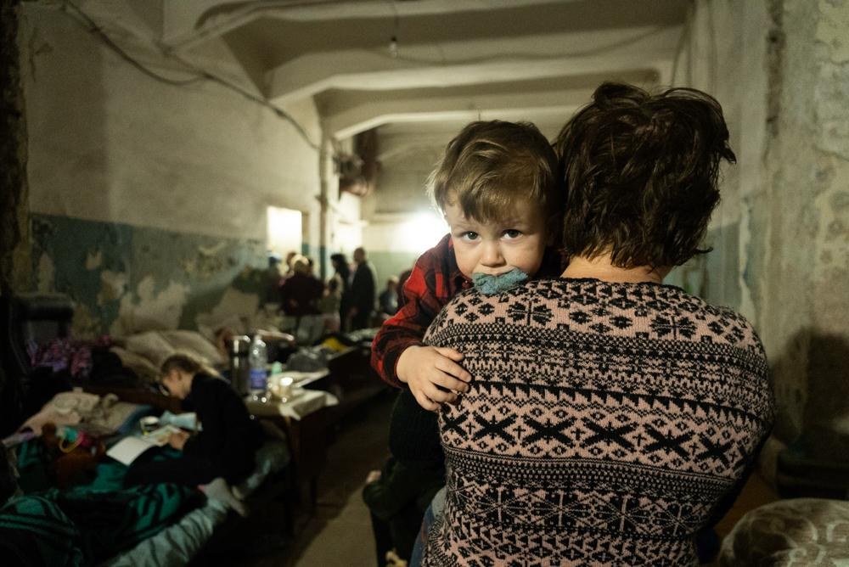

A woman holds a child in an improvised bomb shelter in Mariupol, Ukraine, 7 March 2022. Photo: Mstyslav Chernov

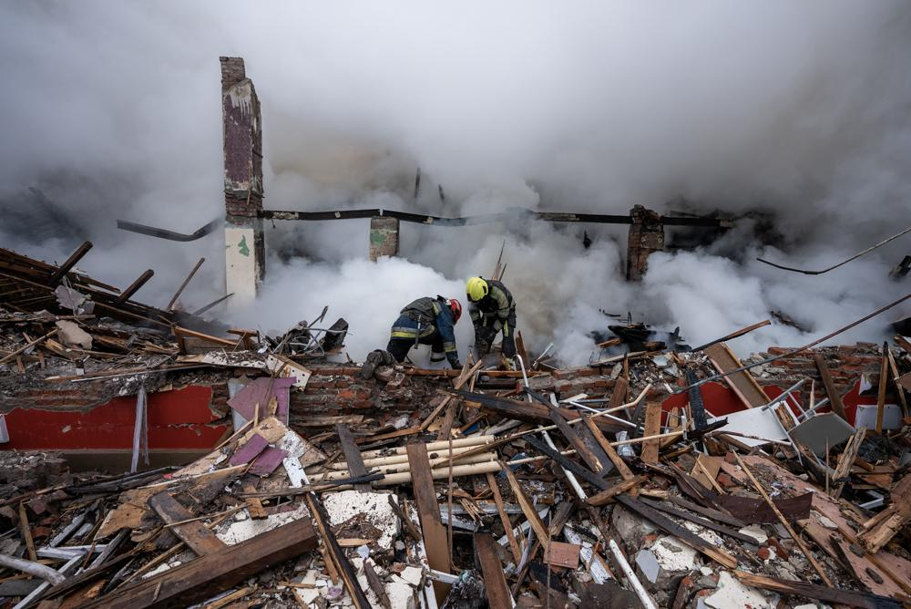
Firefighters clear the debris and search for bodies under the rubble of a building hit by a Russian attack in Kharkiv, Ukraine, 12 April 2022. Photo: Mstyslav Chernov

